**Course: DevOps Name: Billipati sai teja**

**Module: JEKINS Mail id:(BILLIPATISAITEJA@GMAIL.COM)**

**Topic: Email configuration Batch No: 115 (9am-10am)**

**Trainer Name: Mr. Madhukar Assignment: 3**

**Date of Submission: 05-12-23**

**………………………………………………………………………………………………………………………**

**STEPS FOR THE EMAIL CONFIGUATION THROUGH JEKINS PIPELINE:**

* Open the instance and connect through the server and login to the Jenkins.
* A screenshot of a computer

  Description automatically generatedAfter login through the Jenkins go through the manage Jenkins and click on the system configuration.
* Go through the system configuration and scroll down and there we can see the **E-mail notification.**
* In that we can see the SMTP server and Port number.
* 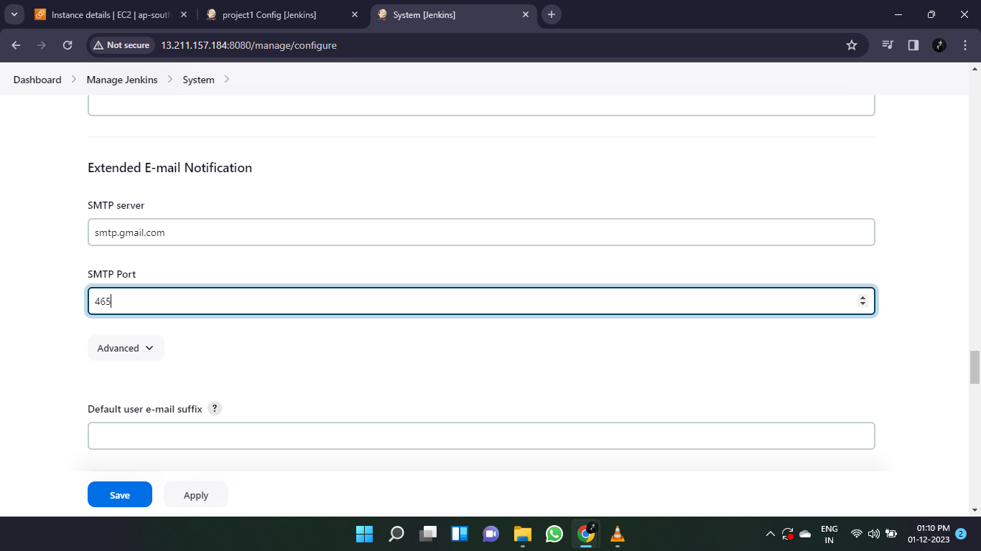The default port number of the SMTP server is 465 and the mail of SMTP server will be delivered default only. We need to type only the port number.
* Click on the Advanced option below the SMTP port.
* In that advanced option there will be credentials we add the Jenkins deployer credentials and save it.

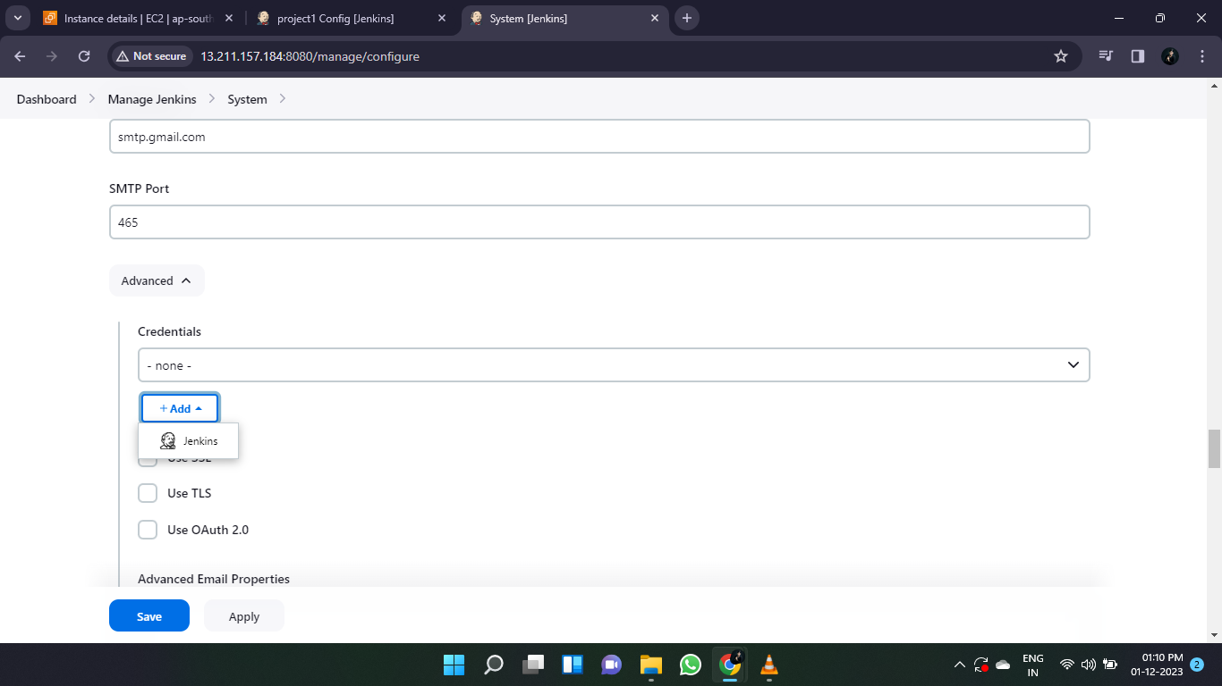

* Now after the credentials creation below the credentials there will be an option SMTP authentication.
* There we need to give the E-mail address credentials of which mail we need.

* Below there will be a reply e-mail address we need to give the same email address which is give in the credentials.

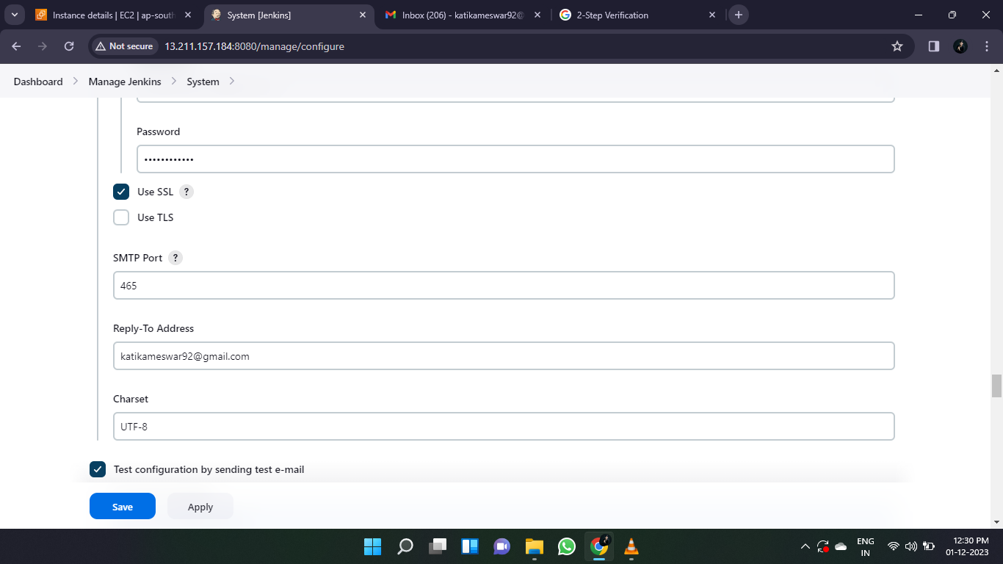

* We need to test the weather the given E-mail address has working or not so for that we will do a test configuration.
* But we give the E-mail address and click on the test configuration it we get an error.

* For sort out this error we need to go through the E-mail credentials and click on the manage account.

* 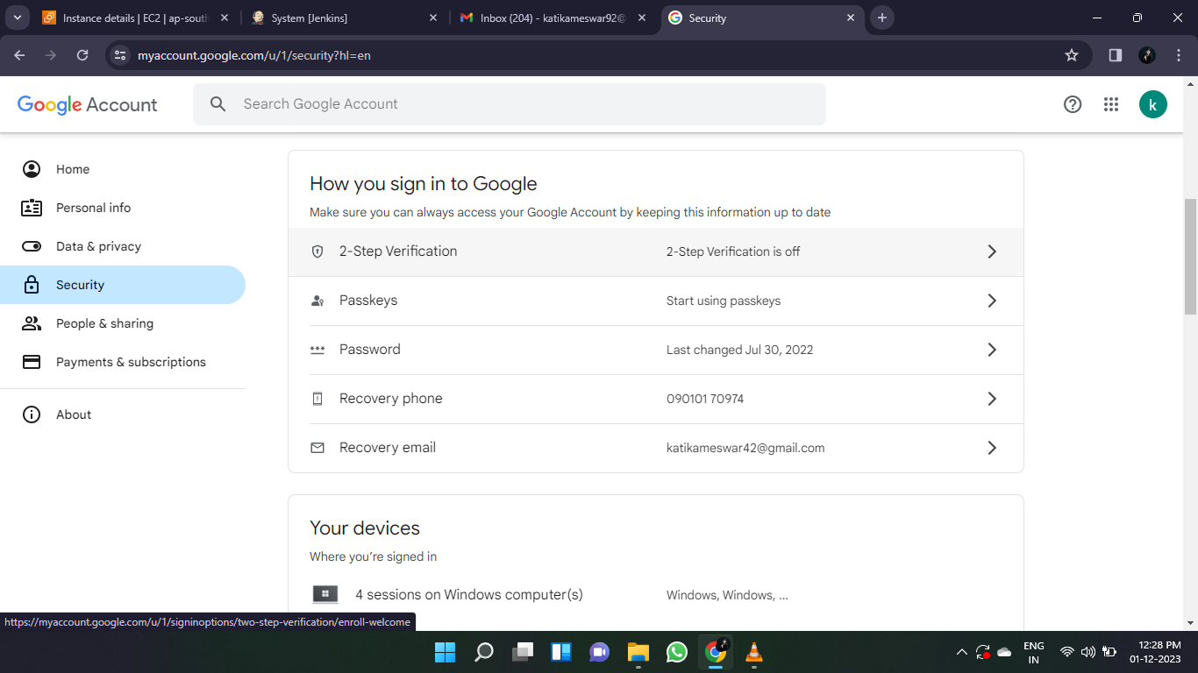Go through the security and click on the 2 – step verification and on it.
* 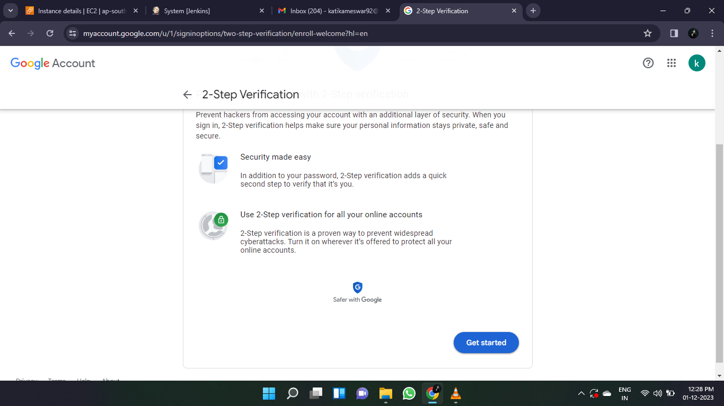In the 2-step verification the interface will be like show below and in that click on get started.
* When we click on the get started it will ask sign-in through the phone to turn on the 2 -verification step click on ok and procced.

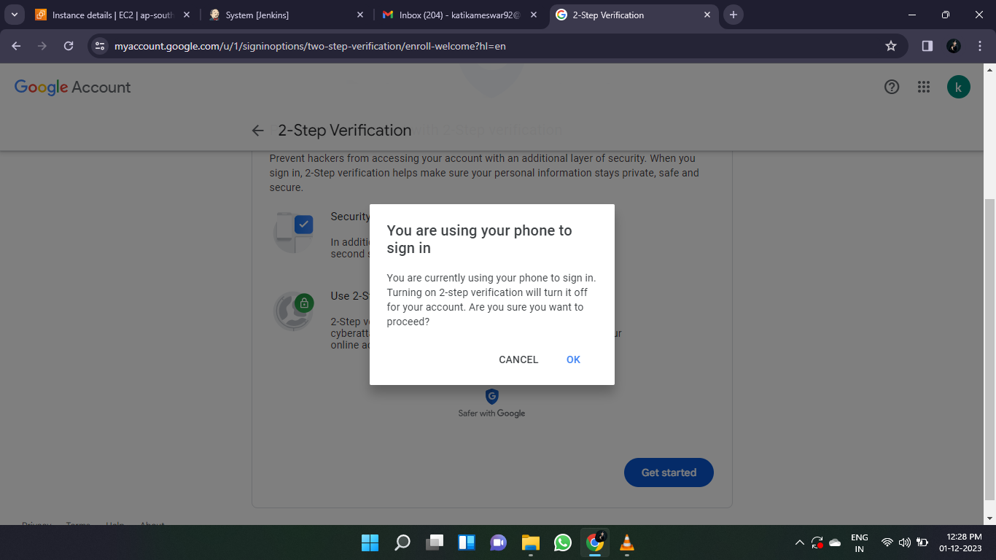

* 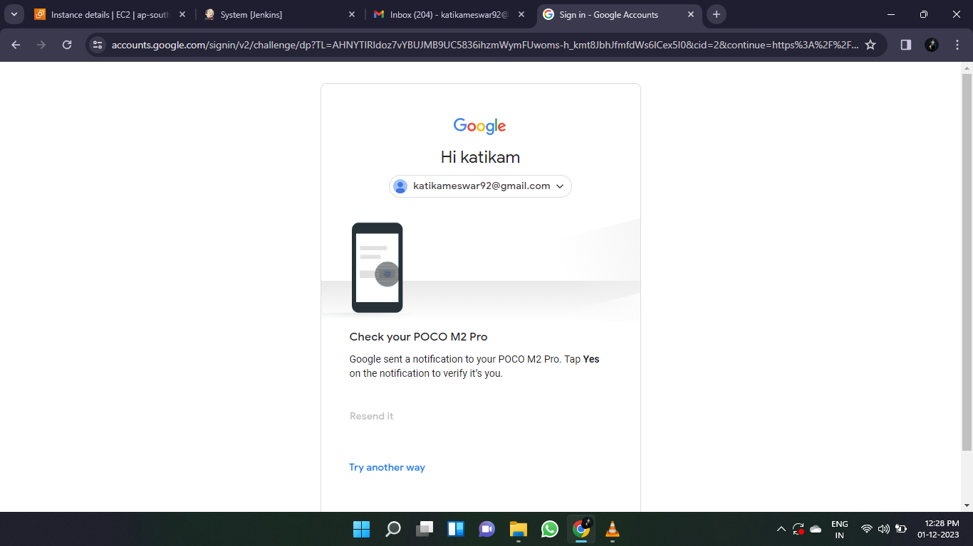We get a notification on our phone to verify that weather we or any unknown user is using click yes on the mobile.
* When we click on yes in our mobile it shows the mobile device that currently we access so conform the device and click on the continue.

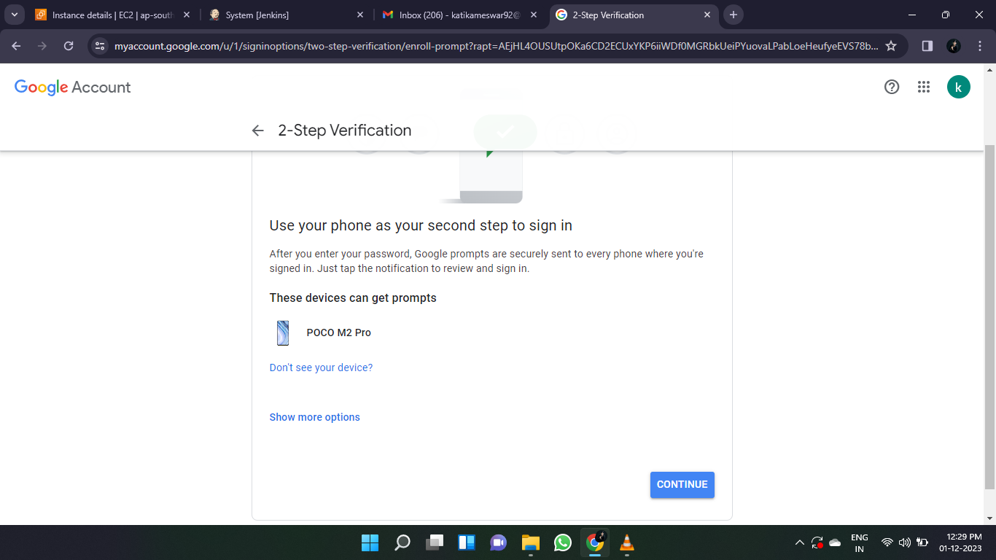

* After that it will shows the backup option to retrieve the account in that will be chose the mobile number and procced.
* Whether we forgotten the E-mail credentials we can retrieve back through the number which we were give.
* We have 2 options text or call we can take which is comfortable to us and click on send.

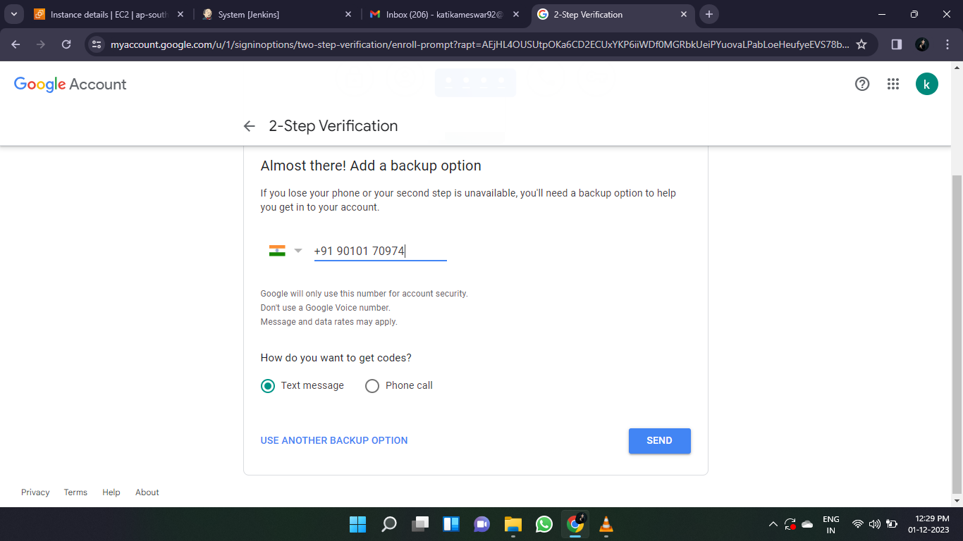

* We get a code to the given mobile and enter it and click on next.

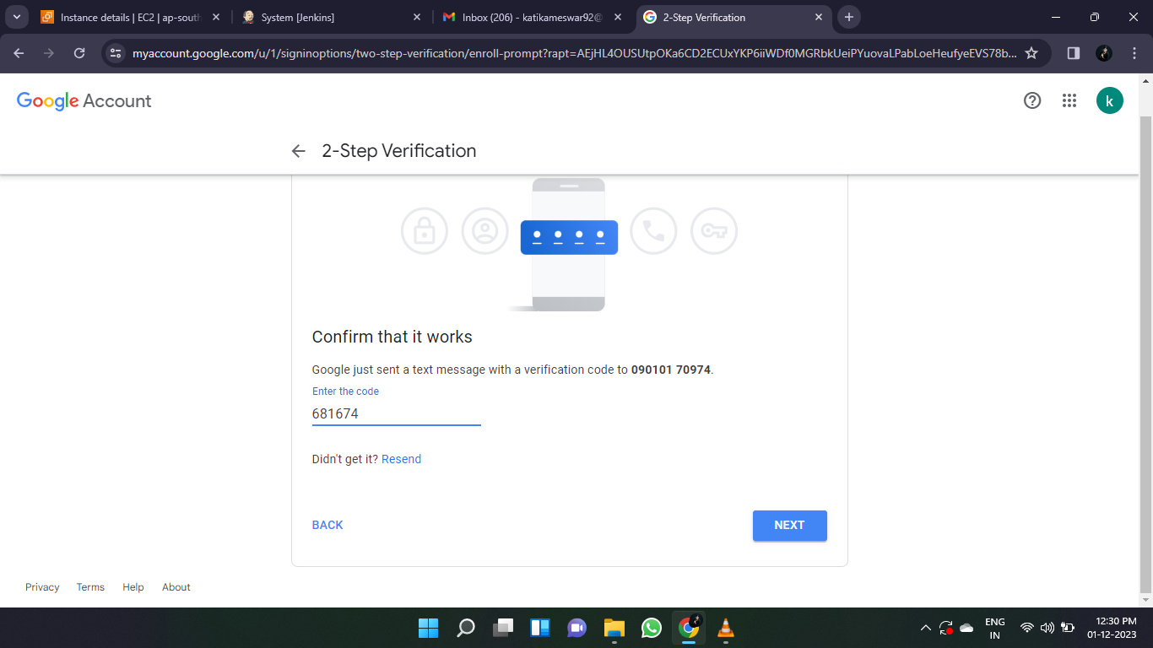

* Now the 2-step verification will be turned on and the device which we are enabled also show below.

* Go through the google prompt click on the app passwords and create a password!

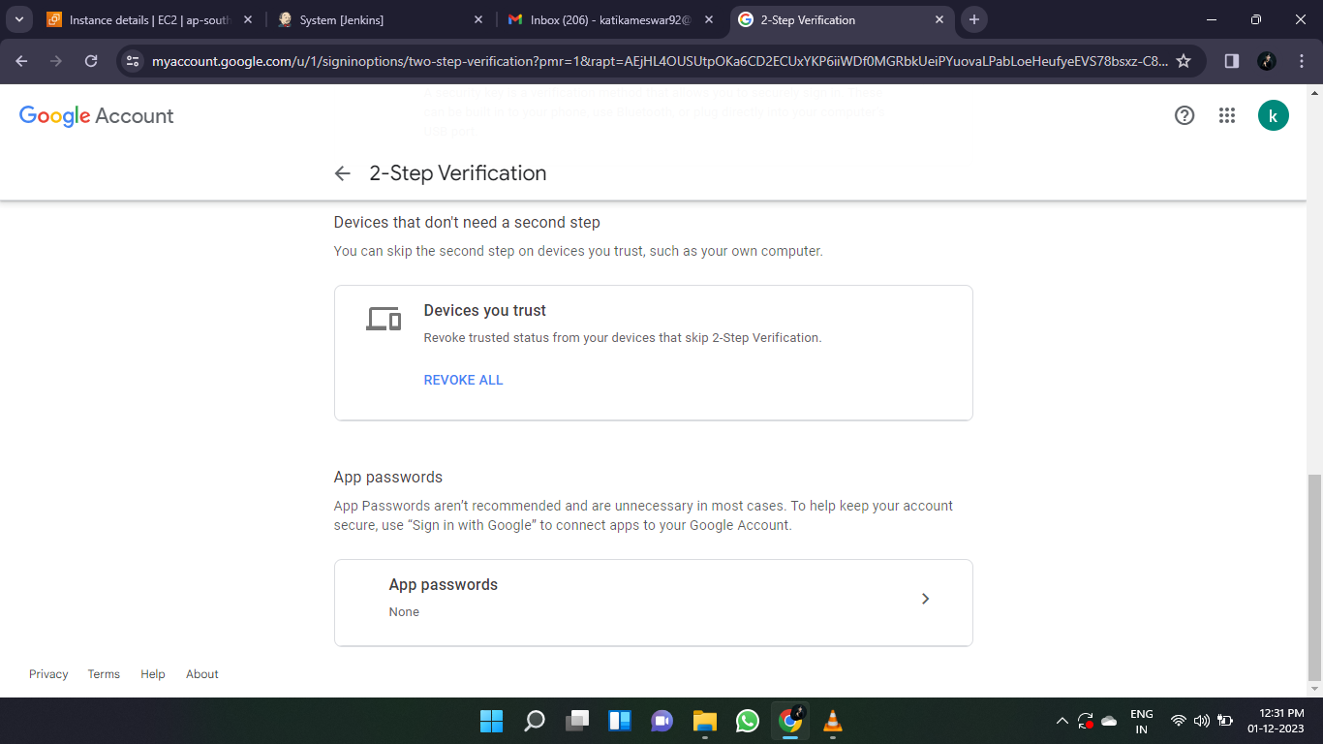

* 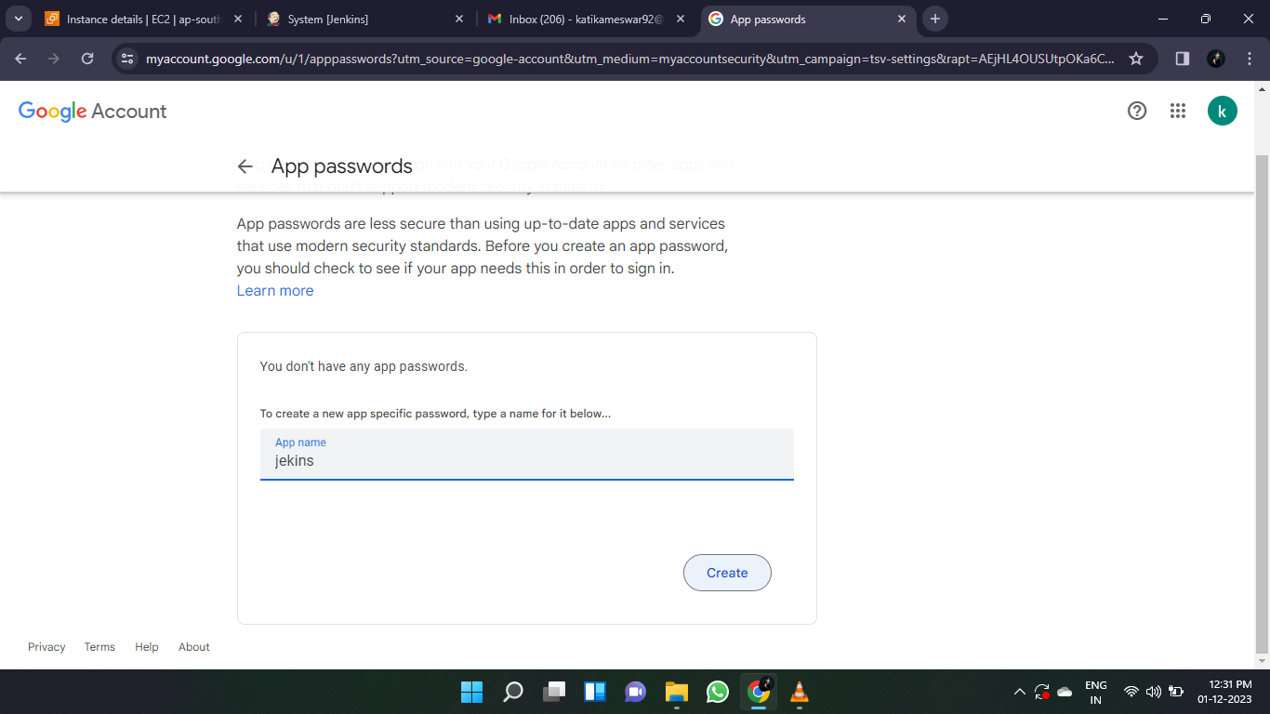Create a new password Jenkins and click on create.
* When create a new password it will generate an app password copy that password.

* Now again go to the system configuration and scroll down to the E-mail notification.
* In that click on advance option and go through the Use **SMTP Authecation.**
* Enter Email: katikameswar92@gmail.com

Paswd: dngbluojcujvwiry (this the paswd generated by app password)

* Give the default port number 465 in the port no.

* Now in the reply address we need to give E-mail address which the notifications to send.
* After all the credentials entered, we need to test the notification is working or not and sending the emails correctly or not.
* 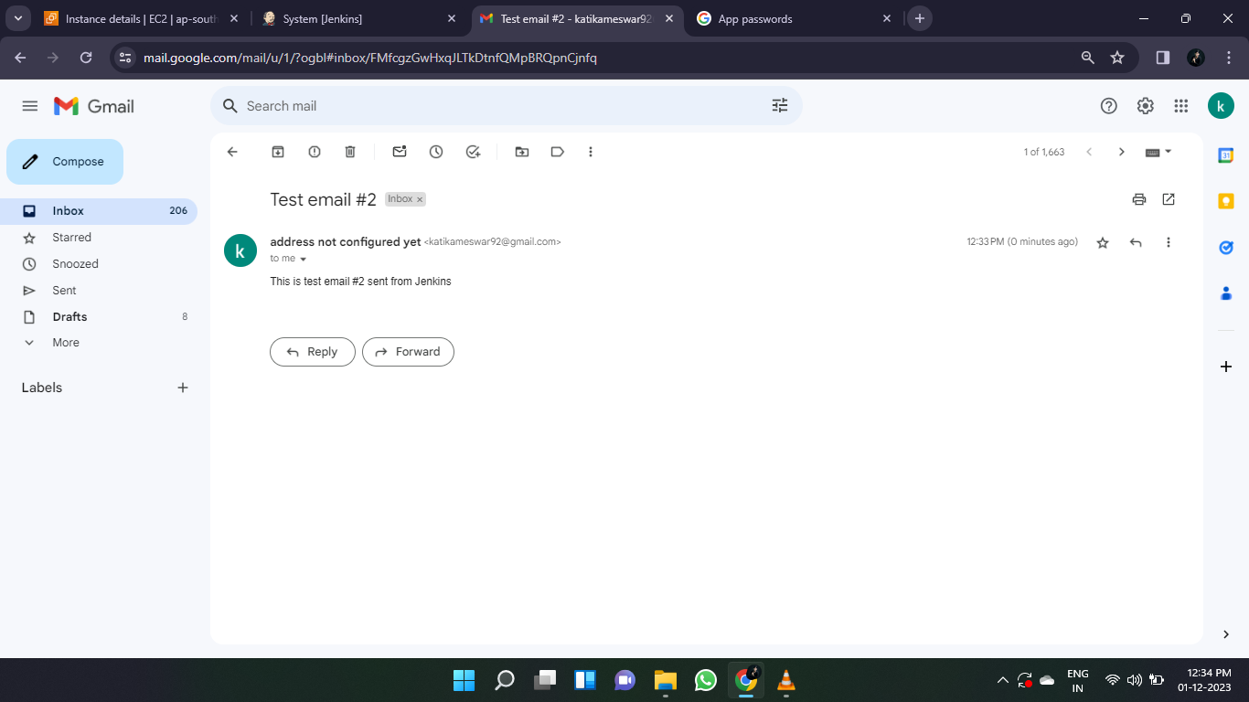For this we had an option **Test e-mail recipient** and the mail-id and click on the test configuration.
* The email is successfully sent to the give credentials of E-mail.
* Go through the default triggers and select the triggers when the file has been built.

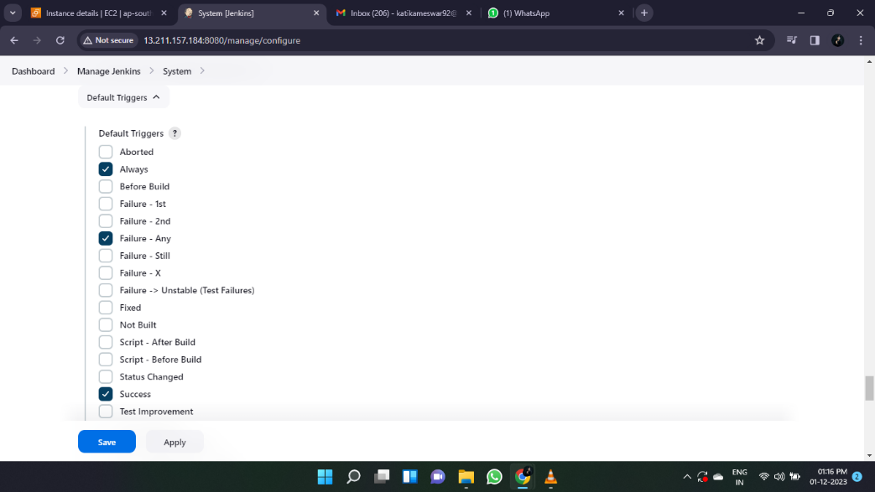

* Now click on the apply and save and test.

**E-mail configuration in the Jenkins pipeline**:

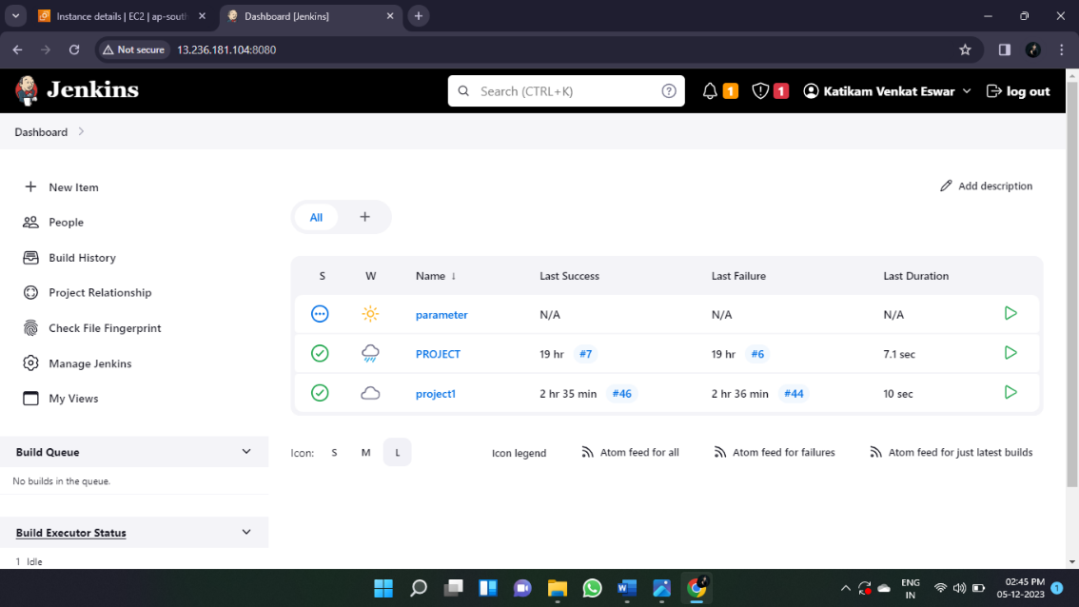

* Click on the current project or create a new project which is a pipeline project and go through the pipeline script.

**PIPELINE SCRIPT FOR THE E-MAIL CONFIGURATION:**

pipeline {

agent any

stages {

stage('checkout’) {

steps {

checkout scmGit (branches: [[name: '*/DEV']], extensions: [], userRemoteConfigs: [[credentialsId: '35ec10a9-48ac-4423-a432-6a37b31cc3ce', url: 'https://github.com/Venna12/taxi-booking.git']])

}

}

stage('Build’) {

steps {

sh 'mvn package'

}

}

}

* Go to pipeline syntax and in the sample, steps select the **mail: Mail.**

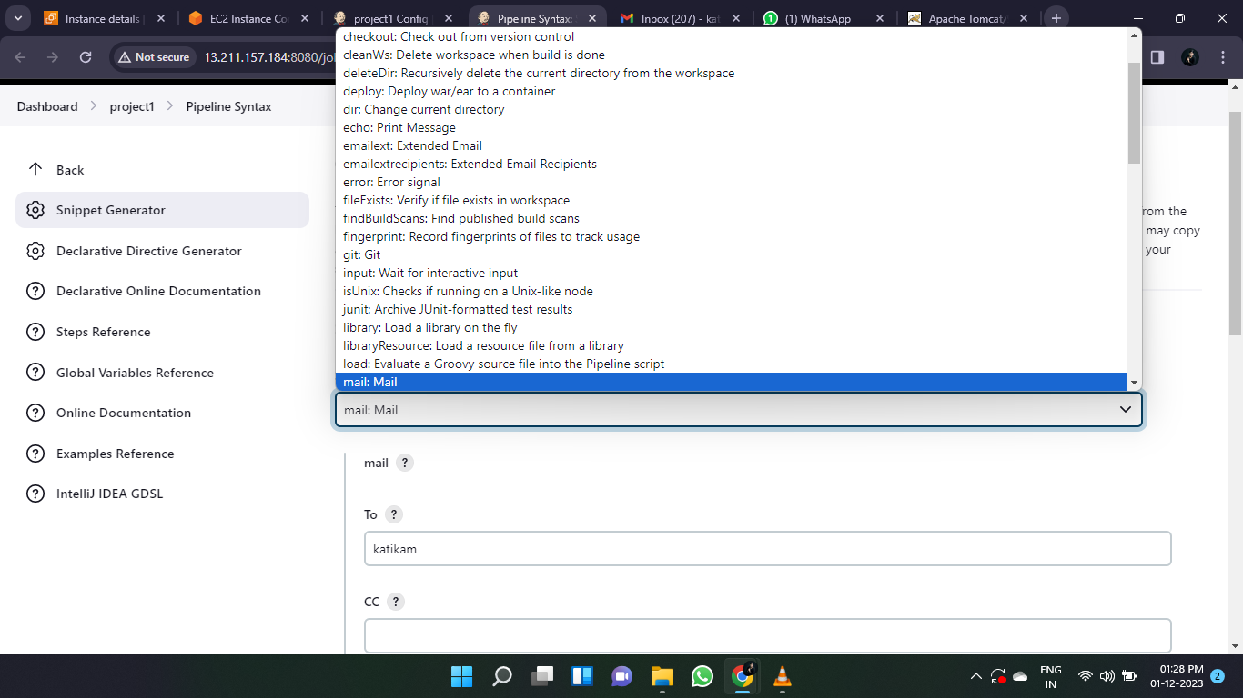

* In the pipeline syntax after the stages, we need to the script for the E-mail configuration as shown below.

**E-MAIL CONFIGURATION SCPRIT:**

post {

always {

script {

if (currentBuild.currentResult == 'SUCCESS') {

step ([$class: 'Mailer', notifyEveryUnstableBuild: true, recipients: 'katikameswar92@gmail.com', sendToIndividuals: true])

}

else if (currentBuild.currentResult == 'FAILURE’) {

step ([$class: 'Mailer', notifyEveryUnstableBuild: true, recipients: 'katikameswar92@gmail.com', sendToIndividuals: true])

}

}

}

}

}

* Now build the file.

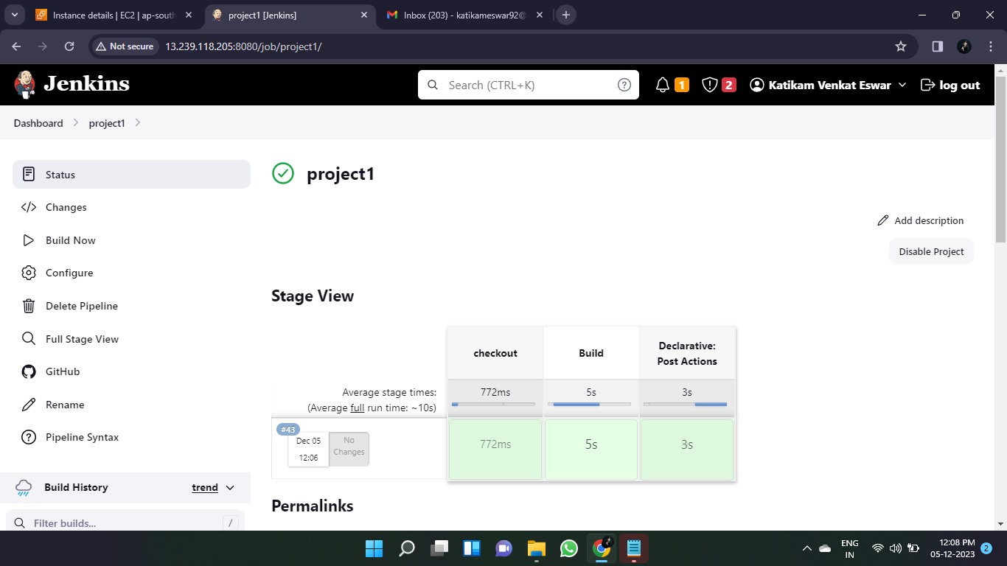

* When the build is successfully completed.

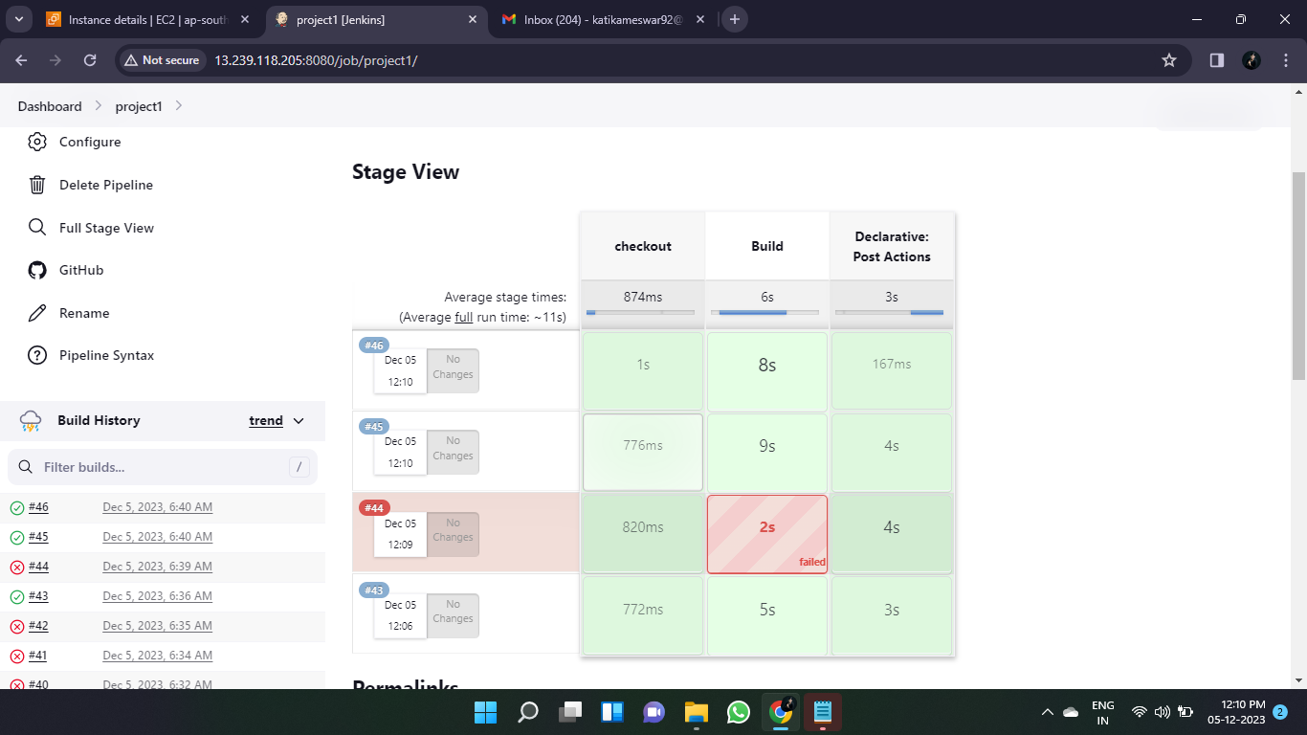

* The build has successfully completed, and E-mail also successfully notified.

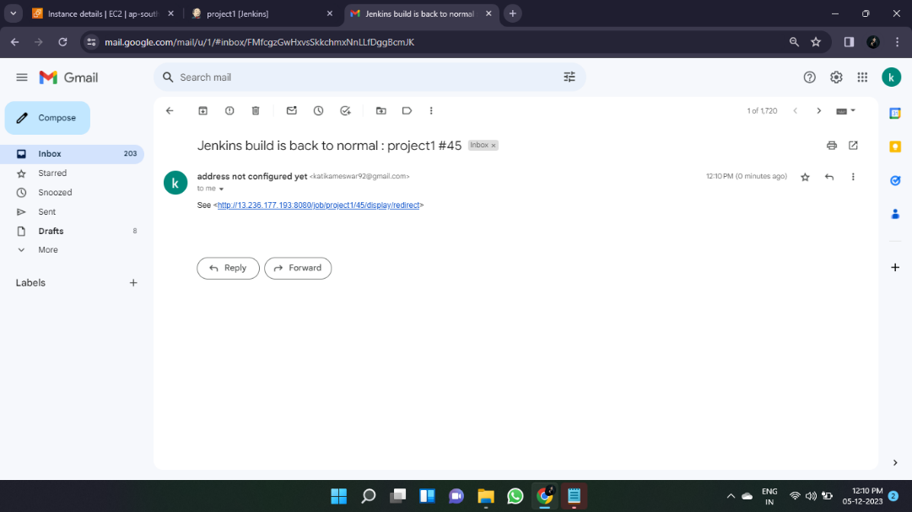

* When the build is failed.

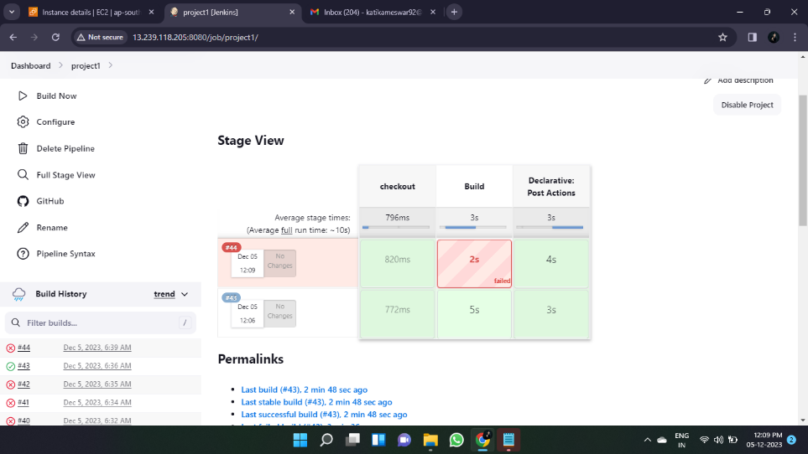

* The build failure occurs means the errors which errors and where are the errors the entire information will be sent to the E-mail address.



